Documentation

housing.com

searching appearence

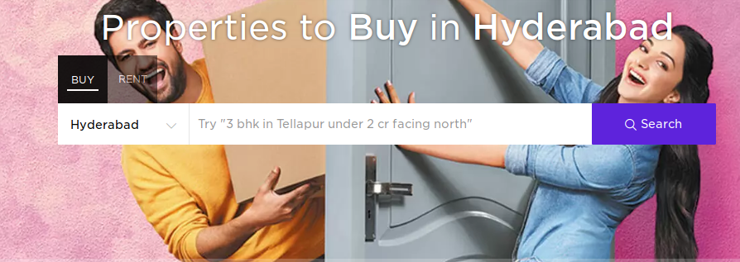

main search option

- buy
- rent

secondary search option

- after selecting buy or rent option secondary search option comes in filed

- select location/ place which is exist default
- select prefered house ( click search )

result as per search information

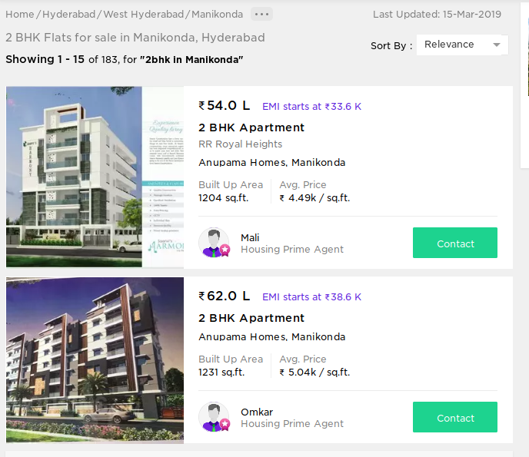

- in image information is very clearly shown as per search option provided
- showing 1 -15 related option are shown

- 2bhk in manikonda
- including price list which is not defined in search

Registration page
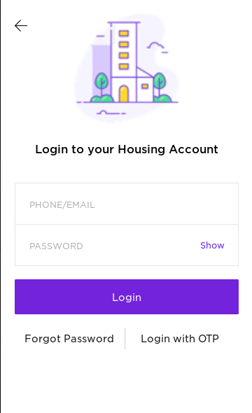
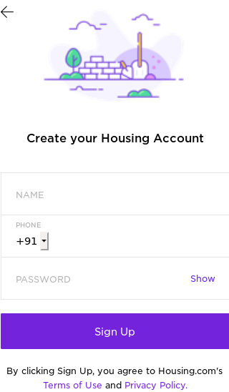

In left image has few options for registration
- name
- mobile number
- password

In right image login as multiple option

- login through social media
- login through OTP
- login through mobile number

99acers.com

search appearence

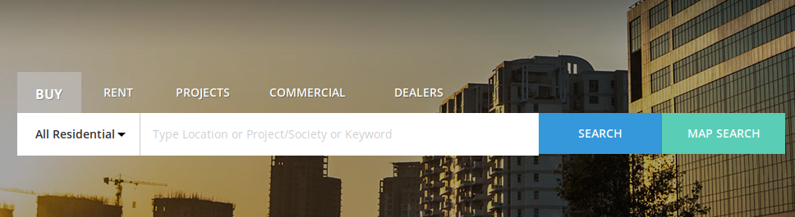
image three major search options are available

main search option

- Buy
- Rent
- Projects
- Commercial
- Dealers

Secondary search option
- Residential
- location/project/socirty/ any keyword
- map search

sub search for secondary search option( to improve accurasy )

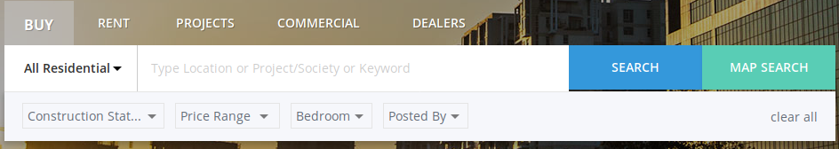
- Construction status
- price range
- bead room
- posted by

Result according to search options

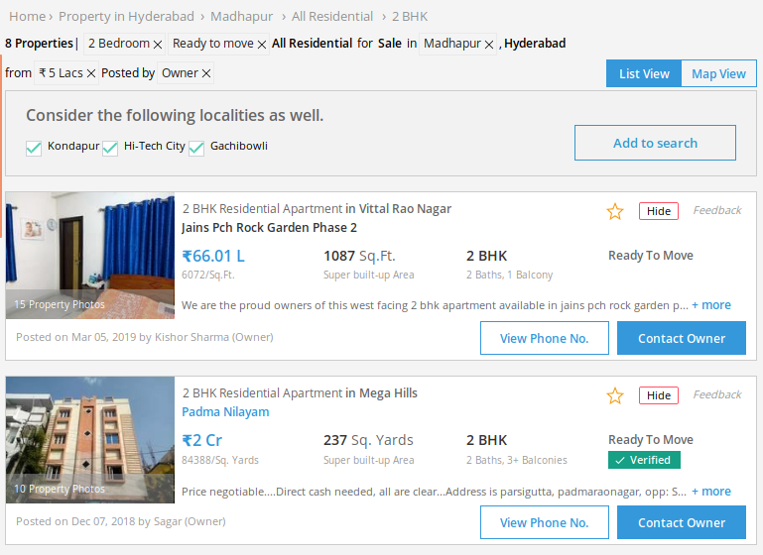

- in image information is very clearly shown as per search option provided
- showing related option are shown

- 2bhk in gachibowli
- we provide 5lacs price in search
- results shown least price in the perticular area

Regitration page
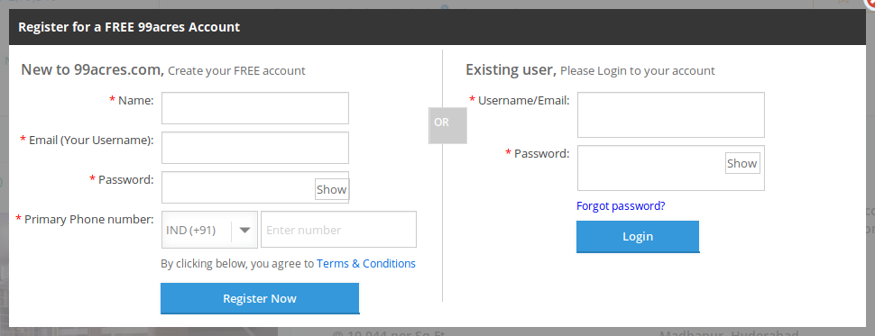

In this page it has many options for registration
- name
- email
- password
- mobile number

login pages

- has user name
- password
- forgot password

selling properties/ uploading properties
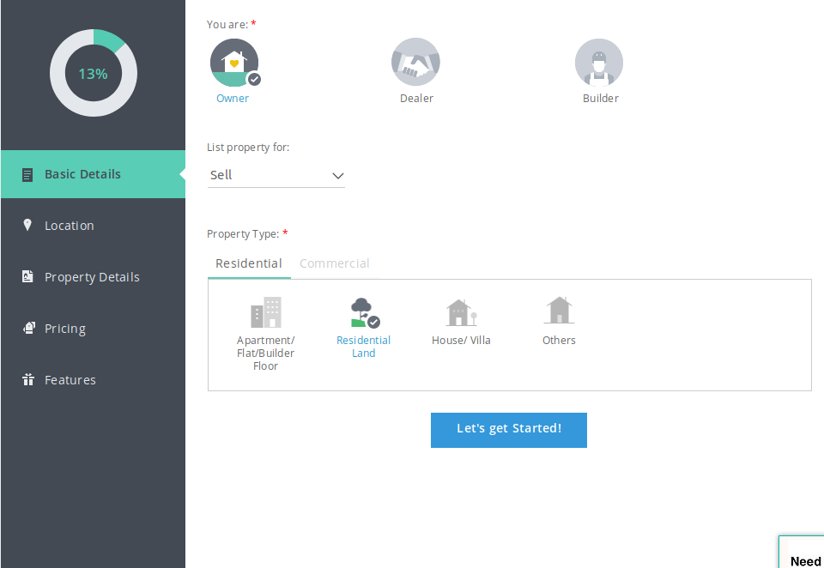
- who is selling
- property type
- details
- location
- pricing
- features

